Belle Isle TMO 

Tenant Satisfaction Measures (TSM’s) Update August 2026-27

Tenant Satisfaction Measures are required to be reported by the Regulator of Social Housing.

There are 22 tenant satisfaction measures, covering five themes. Ten of these are measured by landlords directly, and 12 are measured by landlords carrying out tenant perception surveys.

Tenant Perception Surveys

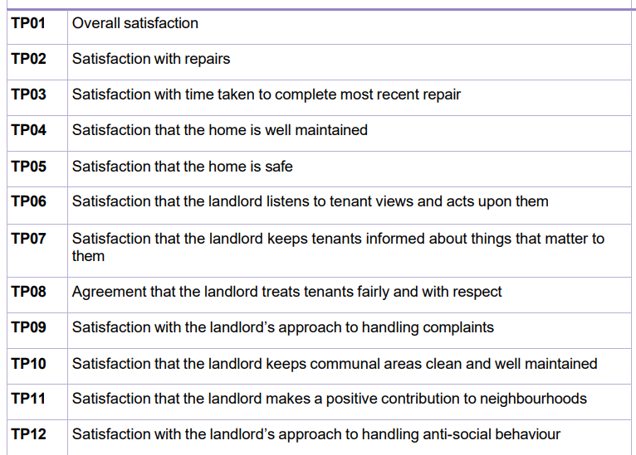

There are also 10 Management Information Measures required to be reported to the Regulator (via LCC). These are incorporated with the BITMO Key Performance Indicators and are not therefore dealt with in detail here.

Tenant Perception Surveys

A rolling system of gathering sample data on behalf of LCC and BITMO tenants is undertaken by the firm Acuity. The twelve tenant perception measures are highlighted in yellow.

Commentary

The results for the first six months of 2026-27 are very encouraging. It should be noted that the results for the period above have a potential margin of error of some 7.6%, compared to 5.1% for preceding periods. This is because of the difference in sample sizes when comparing a full year to a part year.

Overall satisfaction has increased by 5% to 80% for the six months. Repairs satisfaction levels have increased, although there is a dip in those who consider that the landlord provides a safe home. This will be examined in more detail.

There is a welcome improvement in satisfaction with complaint handling and also in relation to our approach to dealing with anti-social behaviour.

Longer term trends

Monitoring of longer term trends is vital to understand how our services are received compared to previous periods. The questions asked in addition to the twelve TPM’s give greater context in terms of numbers of repairs, complaints etc.

It is good to see the continued increase in overall satisfaction over the three and a half years that the surveys have been conducted, although we know that many challenges remain.

