**Five Year Plan Review**

|  |  |  |
| --- | --- | --- |
| **BITMO**  Board of Management Report | | logo 2 |
| **Meeting Date: 27h March 2025** | | |
| **Report Title:** | Revised 5 year plan | |
| **Author(s):** | Deborah Kelly | |
| **For Information/ Decision/ Discussion** | | |
| **Executive Summary:**  The report provides a framework for a new five year plan, based on the revised vision and objectives approved by the Board in January. It identifies key projects to be undertaken and the measures of success against which delivery will be evaluated.  It links to the revised risk map, also approved in January, and the need to evidence compliance with the consumer standards. The risks in the risk map where the residual risk is rated medium are: board succession, quality of accommodation, quality of estate management, and compliance with operational procedures.  Measures of success are included in the revised plan. Projects and work themes are determined annually. | | |
| **Recommendations:**  Board is requested to APPROVE the framework for the five year plan and COMMENT on the projects identified as being delivered in 2025/26. | | |
| **Equality Diversity and Inclusion**  There are no implications for EDI. | | |
| **Risk**  The majority of risks are managed through the standard operating procedures and quality assurance arrangements in place as “business as usual”. The risk map identifies 4 risks that have a residual risk of medium. The five year plan will incorporate actions to manage these risks. Once these actions are in place they will become an established part of the business as usual control environment. | | |
| **Financial implications**  Financial implications will be identified as the plan is developed. | | |
| **Regulatory Framework:**   |  |  |  |  | | --- | --- | --- | --- | | The Safety and Quality Standard | Checkmark with solid fill | The Tenancy Standard | Checkmark with solid fill | | The Neighbourhood and Community Standard | Checkmark with solid fill | Transparency Influence and accountability standard | Checkmark with solid fill | | The Tenant Satisfaction Measures Standard | | | Checkmark with solid fill |   The five year plan will improve customer service, stock knowledge and investment and empowering the community thereby having direct relevance to the consumer standards. | | |

**Introduction**

A revised risk map and strategic framework has been approved by the Board. Its renewed focus is to build a safer stronger greener Belle Isle, where people want to live, and to do this by investing in people’s homes, building tenant control, and supporting people to live well. These are BITMO’s objectives.

Mission: Build a safer stronger greener Belle Isle, where people want to live – **This reflects the pride we feel, community pride, and the high demand we experience for our housing.**

Objectives:

* Building tenant control - **This puts tenant control front and centre and is absolutely what we are about**
* Invest in people’s homes – **This gives a clear focus on stock condition, investment and safety, and emphasises the importance of the people who live here.**
* Help people to live well –**Everything we do as TEAM BITMO puts the customer first , whether we are in repairs or community development, rents or tenancy support, what we do is help people**

The actions in the five year plan will flow from this renewed focus. The renewed focus has evolved. It is not a break from previous strategy. It incorporates the themes of Getting the basics right” “Our green agenda”, “Bitmo people” and “Empowering our community” . The one theme that has been “de-prioritised” following extensive engagement that evidenced that it is not a high priority for the community is “digital inclusion”. We will continue to support digital inclusion as business as usual through the GATE, and promotion of the portal but do not plan for any specific new projects at this time .

**Business As Usual**

**Getting the Basics Right -** This theme will continue the work stream of focusing on improving operating procedures, customer information and staff training.it will support each of our three objectives

The impact of this work stream will be seen in improved business performance across most metrics, robust quality assurance processes and an audit programme that provides a good level of assurance on the control environment in operation.

**Our Green Agenda -** This theme will focus on investment in the homes people live in, increasing bio-diversity on the estate and reducing carbon usage in the office. Success will be measured through an annual assessment of carbon reduction

**Empowering our community**- As a tenant led organisation empowering the community is key to our purpose. This theme is focused on the weaknesses identified in the governance review in 2024, specifically weaknesses in the engagement of Board members, and the broader tenant involvement structure that supports the board. Success will be measured through a further governance review in 2026.

**BITMO People** - Having achieved excellent levels of colleague satisfaction and engagement, we are ready to move to the next level. The next level is enhancing professionalism, talent management and continuing low levels of absence.

Success will be evidenced through the annual Work Buzz survey, attendance figures and training delivered.

**New projects**

As an organisation, we are well run, performing strongly, with a stable a staff team. We face considerable challenges in terms of social housing regulation, evidencing compliance, and needing to demonstrate continuing quality and improvement in a challenging social and economic context. It feels appropriate to focus our activity where we can have most impact. To do this we need to focus on fewer projects that will really deliver for our community and colleagues.

The plan on the next page identifies the key areas of focus in the first year of the five year plan. The five year plan is a “work in progress” and will be further developed with Board, colleague and tenant engagement. We will further develop the measures of success and key metrics that will be presented to the Board throughout the year to provide assurance that we are delivering the mission and objectives and the impact is clear, evidenced and communicated.

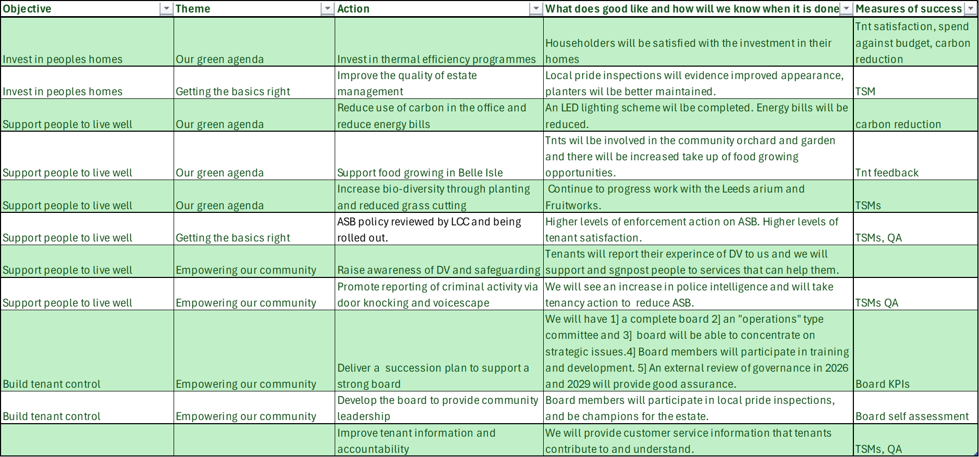

**TSM – Tenant Satisfaction Measures**

**QA – Quality Assurance**

**KPI’s – Key Performance Indicators**