**Belle Isle TMO **

**Tenant Satisfaction Measures (TSM’s) Update 2024-25**

Tenant Satisfaction Measures are required to be reported by the Regulator of Social Housing from 1.4.24.

There are 22 tenant satisfaction measures, covering five themes. Ten of these are measured by landlords directly, and 12 are measured by landlords carrying out tenant perception surveys.

**Tenant Perception Surveys**

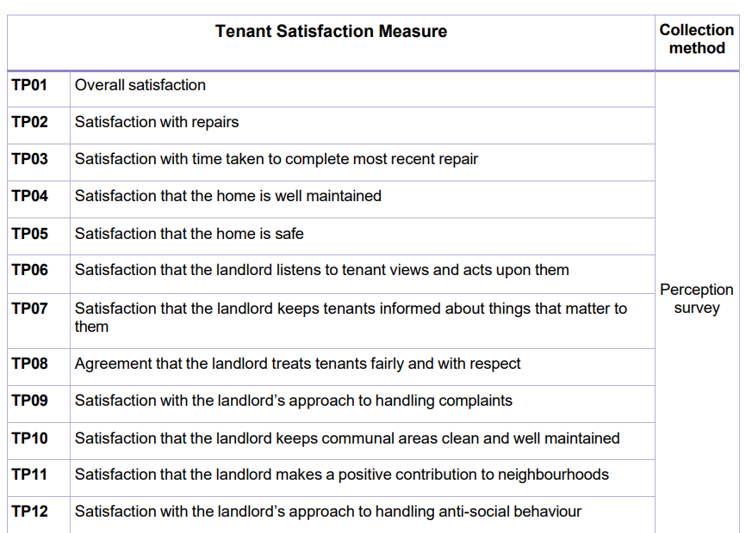

There are also 10 Management Information Measures required to be reported to the Regulator (via LCC). These are incorporated with the BITMO Key Performance Indicators and are not therefore dealt with in detail here.

**Management Information Measures**

* CH01: Complaints relative to the size of the landlord
* CH02: Complaints responded to within Complaint Handling Code timescales
* NM01: Anti-social behaviour (ASB) cases relative to the size of the landlord
* RP01: Homes that do not meet the Decent Homes Standard
* RP02: Repairs completed within target timescale
* BS01: Gas safety checks
* BS02: Fire safety checks
* BS03: Asbestos safety checks
* BS04: Water safety checks
* BS05: Lift safety checks

**Tenant Perception Surveys**

A rolling system of gathering sample data on behalf of LCC and BITMO tenants is undertaken by the firm Acuity.





**Conclusion re Tenant Perception Surveys 2024-25**

There are many areas of good and growing performance, whilst there is also continued ambition to enhance performance across all areas of operation.