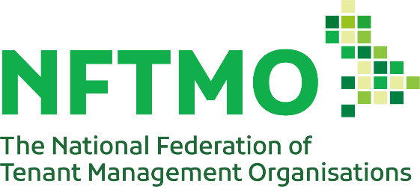
The NFTMO bulletin for members

Members Update
After a brief hiatus in March welcome back to the April Members update. Lots to report this month as we see the introduction of the new Regulatory regime for social housing, move into the new tax year and we continue preparations for the Annual Conference.
We really want to recognise the wealth of good practice that TMOs provide so see the next page for details of this year’s NFTMO Awards and nomination forms can be found on the website.

Pictures Wanted
Do you have photos of your TMO in action (Fun Days, Events etc) that we can use for our Annual Report?

The NFTMO Needs You!
Last month we asked if you had considered becoming a Director of the NFTMO? Well, since then, we’ve been made aware of at least two Directors who will be stepping down from the Executive Committee. Andrew Slater (Dovecotes) is stepping down for health reasons and Simon Oelman (Roupell Park) is retiring. Whilst we wish them well and thank them for their services, it does mean that we really do need others to step forward to replace them.
The Executive meets 6 times per year over zoom – usually on a Tuesday at 11.30. We hold a residential weekend once a year (Friday and Saturday) where we’re able to look at issues such as Business Planning in greater depth. At present our Articles require us to seek members from the North, Midlands and South regions. Whilst tenants are always in the majority, TMO Managers can also become a Director.
If your TMO would like to nominate someone to become a Director of NFTMO then please complete and return the nomination form which can be found on our website here.

Membership Update
We’re pleased to announce that membership numbers are up this year with almost 90 TMOs having paid their annual subscription. Thank you to those have renewed and welcome to new members and those rejoining after an absence.
The NFTMO Executive has agreed to make this update available to all TMOs for the coming year and your TMO can apply for membership at anytime.
Housing Ombudsman
The Complaint Handling Code has now come into force so make sure that your TMO is compliant.
The Housing Ombudsman service reports that it will be doubling the number of decisions it makes this year and casework continues to rise as tenants rightly refuse to accept poor services.
Just published is the follow-up report to the “Time to be Heard” investigation into the treatment of noise complaints. This considers a number of case studies and is worth reading alongside “Learning from Severe Maladministration” which sets out the key points from the increased levels of maladministration findings.

Gala Dinner
You’ll notice a bit of a change for the Gala Dinner as, this year, there are options for meal choices. All those who have booked places will have received an email asking for the names of the delegates and their food choices for the meal. Please can you return these to us asap. In order for the hotel to cope with this we can not accept any changes after 31st May. Past this date anyone who has not responded will be offered the default menu as set out in the email.
Annual Conference
It’ll come as no surprise that we have sold-out places on the Early Bird bookings. We’ll be placing future applications on a waiting list.
We’ll be kicking things off on Friday afternoon again and running through to Sunday lunchtime.
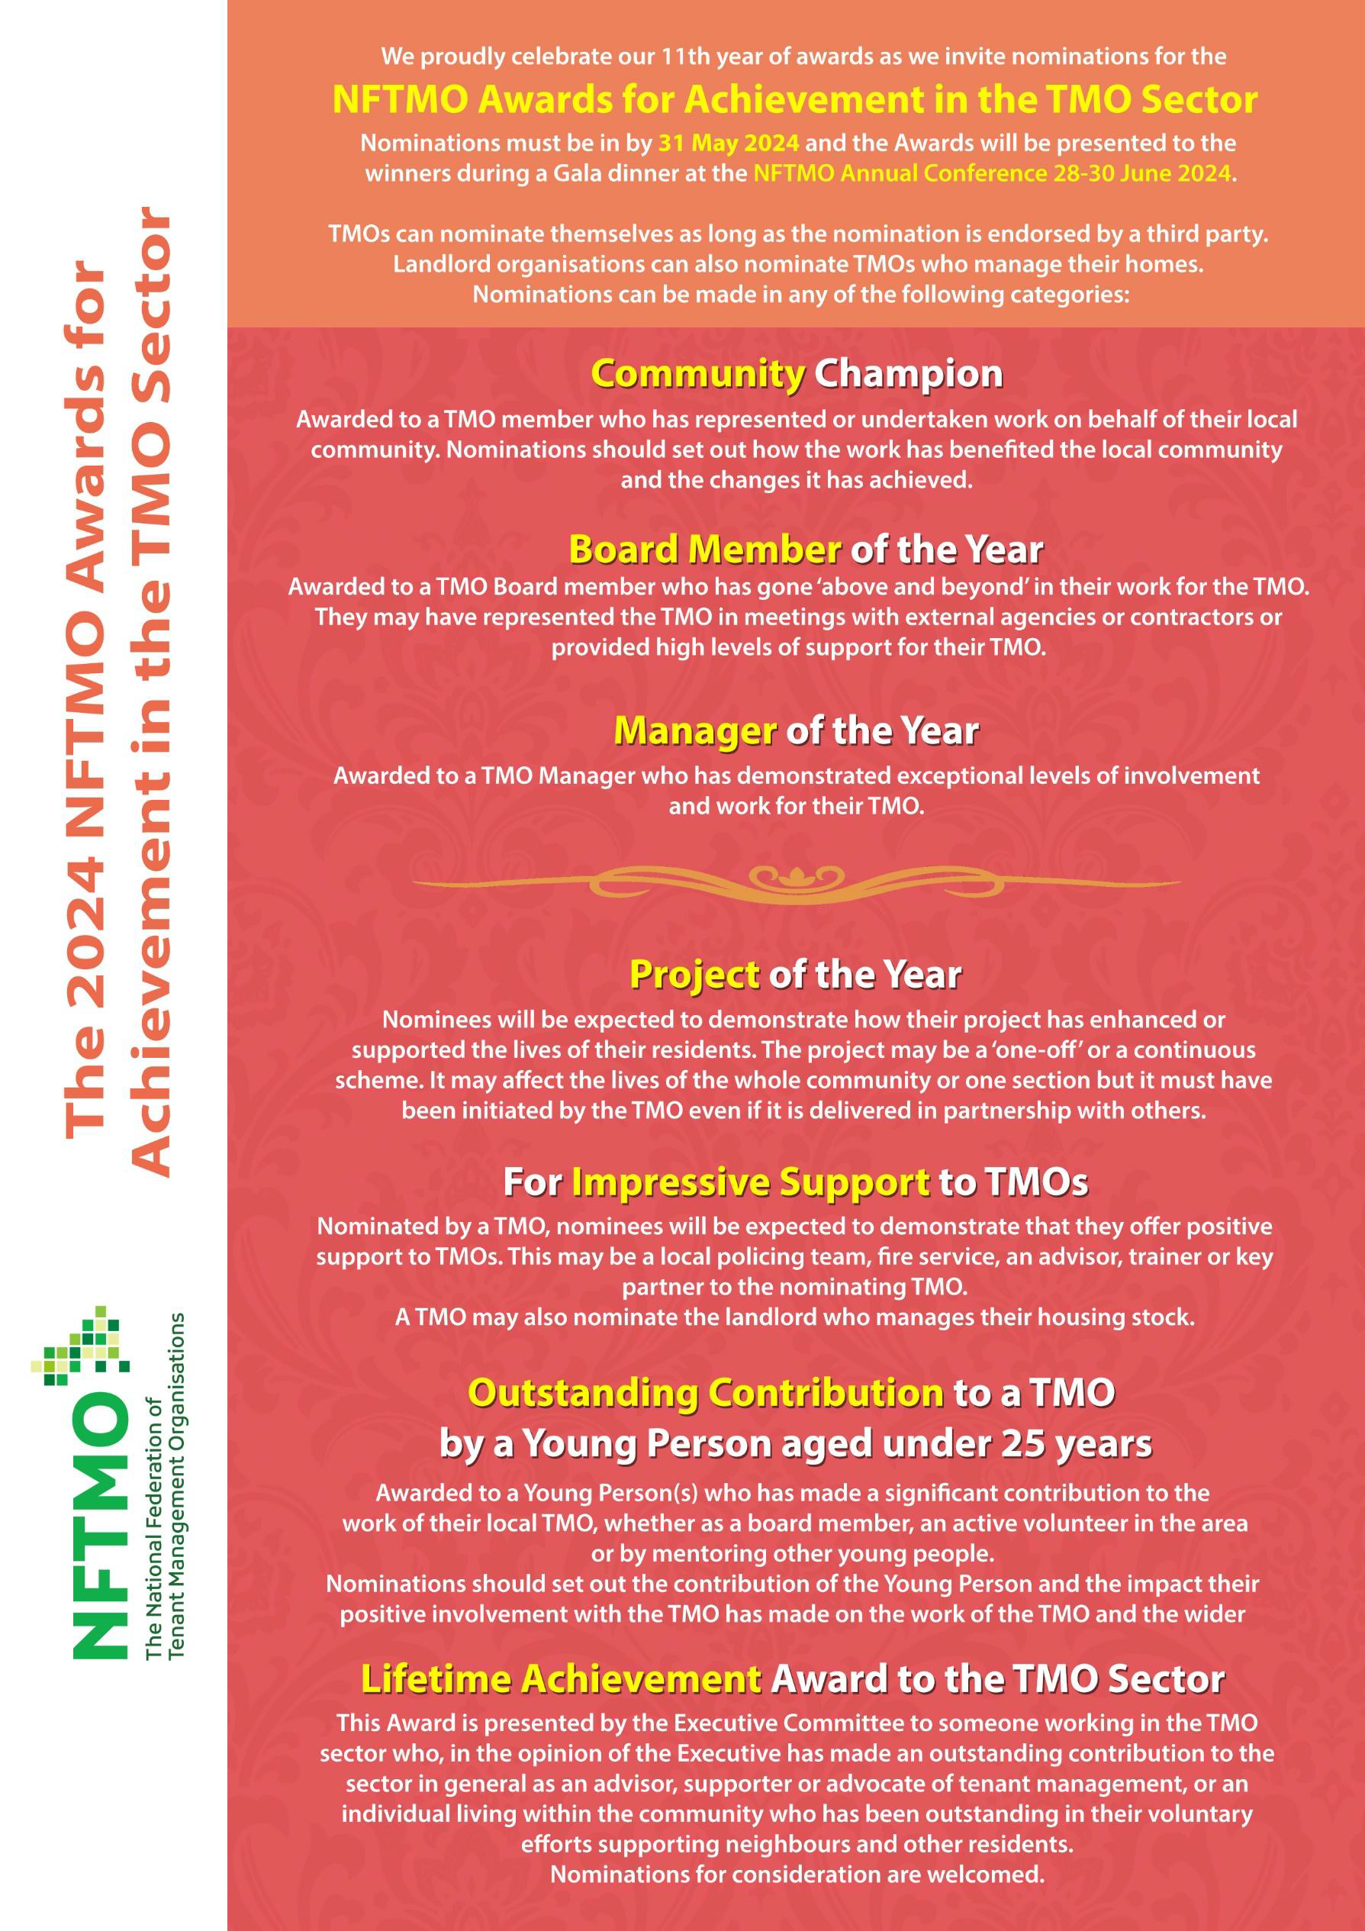
CTR Triangle are hiring!
TMO Co-Ordinator - £34,216 - £37,995
Closing Date 6th May 2024
Located in the LB Newham the estate is a 10-minute walk from Canning Town Station

Chalk Farm Housing Group are hiring!
Estate Manager - £50,000 - £53,000
Closing date 28th April 2024
Located in in LB Camden
NFTMO Awards
You should have received details of this year’s awards categories and we’ll be announcing the winners at the Gala Dinner at the NFTMO Conference in June.
Even if you can’t be there, please do take the time to submit your entry as we seek to promote the range of excellent work undertaken by TMOs.
We’ve increased the number of categories this year to recognise as much of the good work being undertaken as we can.
We would also like to announce the entries that are unsuccessful as well as the winners so please do let everyone know of the work you’ve been doing.
As they say, “A picture paints a thousand words….” So let us have photos as well as the written entry.
We’re notoriously bad as a sector in putting ourselves forward and to recognise that the standards we have become used to would be seen as exceptional by tenants who don’t benefit from tenant management – so let’s change that!

WATMOS are hiring!
Head of Asset Management - £64,835
Closing date 16th June 2024
Based either in Walsall or LB Lambeth.
Consultation Responses
The NFTMO has submitted responses on the introduction of Awaab’s Law and the development of a competency and conduct standard. This follows consultation undertaken by the Department of Levelling Up, Housing and Communities (DLUHC) which we hosted an event on.
The responses can be found on our website and, broadly, supports the introduction of both although we have called for more details around TMOs as we believe that, as it stands, the draft proposals do not adequately reflect the roles of TMOs. We believe they are aimed at senior staff within ALMOs and other large organisations and that as TMOs are generally far smaller any legislation should reflect this.

See you soon!
Lee Page
NFTMO Co-Ordinator
Contact@NFTMO.com
0121 296 7695
07301 277160

