Could you be a Belle Isle Community Builder?

BITMO is looking for a temporary Community Builder, who will work part-time in Belle Isle over a 5 month period. They identify and build on existing assets in the community and engage with individuals and organisations in Belle Isle, with a focus on “what is strong, not what is wrong”. They will identify and work with current Community Connectors and nurture and develop potential Community Connectors. The Community Builder will work with the Belle Isle community as a whole, and will spend the vast majority of their time directly engaging with the community.
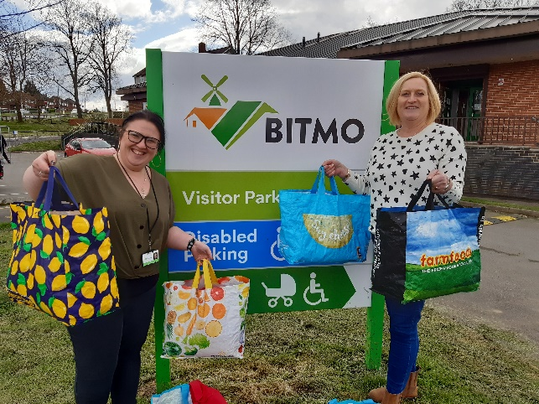 | 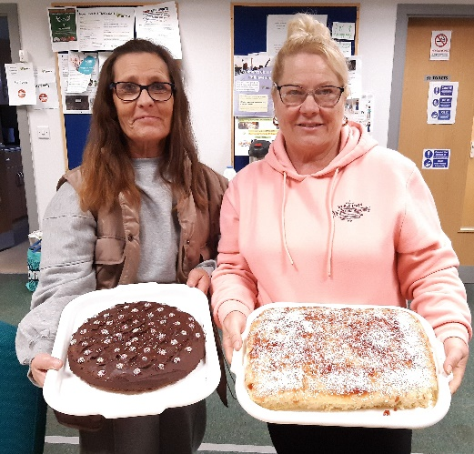
School uniform exchange Belle Isle Community Kitchen

Explanation of some of the words used
This is a fairly new approach to community development in Belle Isle, having been introduced in May 2023. The job description below uses some words and phrases that are explained here.
- Assets – the capacities, skills and talents of individuals, associations, organisations, the natural and built environment, and local businesses within or close to Belle Isle.
- Asset mapping – creating and making widely available a list of all the local assets, which will change over time.
- Spaces for conversation and collaboration – places where people are able to congregate which could be anything from businesses, community centres, park benches or school gates.
- Community Connectors – people living in Belle Isle who voluntarily support others and build relationships between individuals and groups for the benefit of the community.
- BITMO shareholders – tenants within the BITMO area who have bought a 10p share and so are able to attend the BITMO Annual General Meeting and vote.
- BITMO Community Fund – a fund set up by BITMO’s Board to pay for small environmental improvements, support community groups as well as grants to support tenants to go on training courses or buy essential furniture.

Please see the information pack, including the job description and person specification. You can apply on the form on the back of this page or online at LINK

Belle Isle Community Builder Application Form

Please complete all sections of this form and return to Lindsay Woolsey, BITMO, Aberfield Gate, Belle Isle, Leeds, LS10 3QH by 12pm on Friday 12th April 2024.
Name

Address

The Community Builder will focus on “what is strong, not what is wrong” in Belle Isle. Please list THREE things that you think are strong in Belle Isle
1.
2.
3.

Please give TWO examples of when you have motivated people within a community to speak, act or communicate with others.
1.
2.

Please give AT LEAST TWO examples of where you have identified and supported potential community connectors.
1.
2.

Thinking about a small grants process that you have been involved in – in any capacity from administrator to applicant – how would you make the Belle Isle Small Sparks grant fund a success? Please make AT LEAST TWO points.
1.
2.

